Assignment 5

1. **Difference between arguments and parameters**

A parameter is a variable used to define a particular value during a **function definition**.

An argument is a value passed to a function when the function is called.

1. **Why array starts from 0**

An array points to the location in the memory, so in expression array[**n**], **n** should not be

treated as an index, but as an **offset** from the array’s head.

1. **Why private is not allowed with classes**

private keyword can only be accessible within the same class and is not visible to outside world. If we will define a class private, that class will only be accessible within the entity in which it is defined which in our case is its package. So, defining private access to the class will make it accessible inside the same package which default keyword already do for us, therefore there is no benefit of defining a class private it will only make things ambiguous.

1. **Write a program for Prime Number**

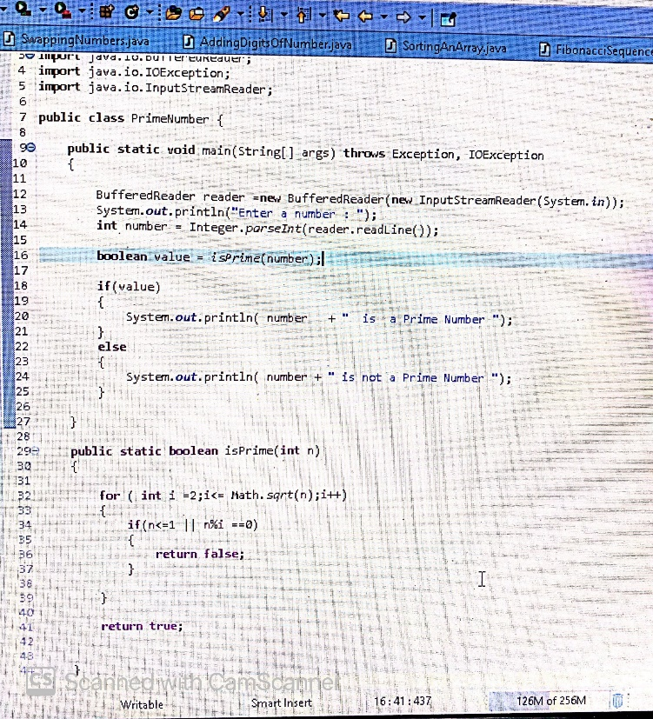

1. **Write a program Fibonacci code 0,1,1,2,3,5,8,13,21,34 till 10th place**

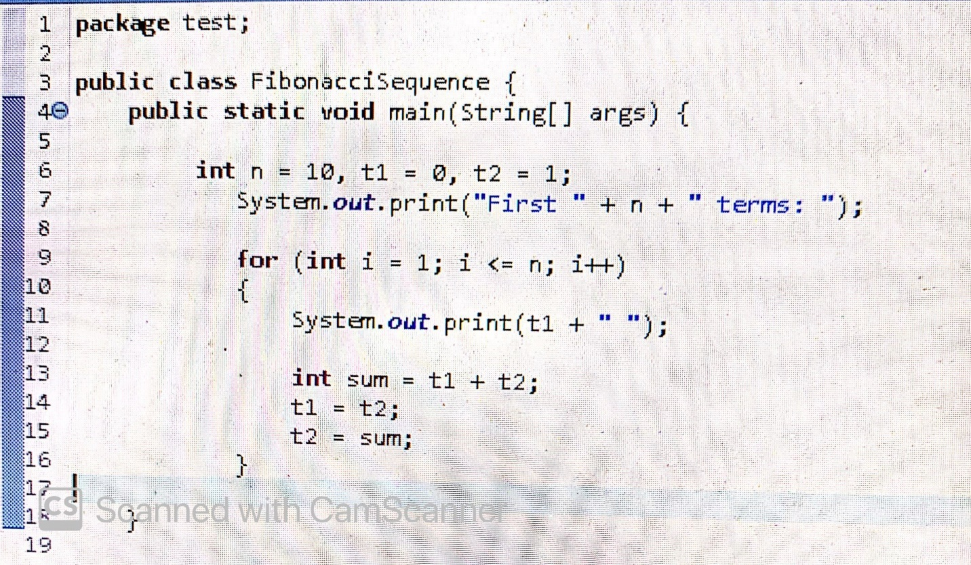

1. **Write a program How to find maximum/minimum value in array**
2. **Write a program How to sort array?**

